Alison McGovern MP
Minister of State for Local Government
and English Devolution in the UK
Cllr Jonny Edge
Jonny.Edge@cambridgeshire.gov.uk
on behalf of
County, District and Parish Councillors
From Burwell and Woodditton County Divisions
Cambridgeshire

Thursday 26th March 2026

Cambridgeshire & Peterborough LGR – Case for Bottisham, Burwell & Woodditton
Dear Alison McGovern,
Thank you for your response of 15 December 2025 to our letter of 20 November 2025.
As a diverse alliance of Parish Councils, East Cambridgeshire District Councillors and Cambridgeshire County Councillors representing just over 19,000 residents we have been monitoring developments closely and, with a decision date imminent, wanted to reiterate our position and to summarise our reasoning.
We attach a map (Appendix 1) to illustrate how geography, rather than politics, drives our collective stance. Our villages, as with the satellite communities of South Cambridgeshire, rely heavily on Cambridge for employment, post-sixteen education, healthcare and leisure services, making us functionally part of Greater Cambridge. The city is a fundamental part of our lives, and we are more closely aligned with Cambridge and South Cambridgeshire than with the wider East Cambridgeshire area.
A decision to combine our area with a northern unitary centred on Peterborough—over 50 miles away—would leave us remote from decision-makers and weaken our voice. Experience elsewhere shows that such distance results in poorer services.
Our annex sets out why Cambridge is integral to our daily lives and why Option 2, or a variation of it (Appendix 2), is the only model that would enable effective and efficient delivery of local services across the area. It best supports the challenges and opportunities arising from Cambridge’s planned growth and offers coherent governance across Cambridgeshire and Peterborough.
If views differ in northern East Cambridgeshire, we believe modifications to the proposals should be considered to reflect geographical practicality.
In summary, Option 2 remains the only consulted arrangement capable of delivering efficient services for our communities and supporting Greater Cambridge’s growth. Parish councils and residents overwhelmingly support this position, and we trust it will be fully considered in your decision-making.
Yours sincerely,
County Councillors
Cllr Jonny Edge (Woodditton division) Jonny.Edge@cambridgeshire.gov.uk
Cllr Yannifer Malinowski (Burwell division) Yannifer.Malinowski@cambridgeshire.gov.uk

District Councillors
Cllr Charlotte Cane MP (Bottisham ward) charlotte.cane@eastcambs.gov.uk
Cllr James Lay (Woodditton ward) james.lay@eastcambs.gov.uk
Cllr John Trapp (Bottisham ward) john.trapp@eastcambs.gov.uk

Parish Councils
Burwell division
Burwell – Chair, Cllr Liz Swift elizabeth.swift@burwellparishcouncil.gov.uk
Reach – Chair, Cllr Tim Quilter reachparishcouncil@reachparishcouncil.org
Snailwell – Chair, Cllr Peter Moggridge peter@snailwellparishcouncil.org
Swaffham Prior – Chair, Cllr John Covill clerk@swffhamprior-pc.gov.uk

Woodditton division
Ashley – Chair, Cllr Sarah Howell e777ans@btinternet.com
Bottisham – Chair, Cllr Nadene Cundell nadene.cundell@bottisham-pc.gov.uk
Brinkley – Chair, Cllr Ian Monks cllrmonks@brinkleyparishcouncil.gov.uk
Burrough Green – Chair, Cllr Tom Rusk tom.rusk@burroughgreenparishcouncil.org.uk
Dullingham – Chair, Cllr Robert Algar cllr.algar@dullingham-pc.org.uk
Kirtling & Upend – Chair, Cllr Richard Staunton rstaunton@kirtlingandupend.co.uk
Lode – Chair, Cllr Fran Platten Fran.Platten@lode-pc.gov.uk
Stetchworth – Chair, Cllr Wayne Bell Wayne_bell@stetchworth-pc.gov.uk
Westley Waterless* – Chair, Cllr Jim Paltridge westleywaterlessparish@gmail.com
Woodditton – Chair, Cllr Dudley White woodditton1947@gmail.com

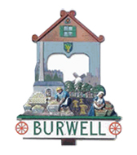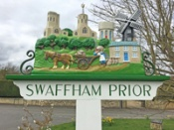

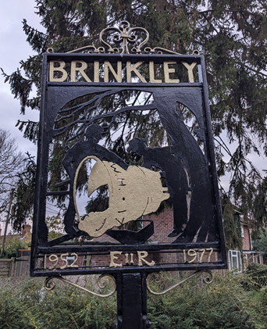

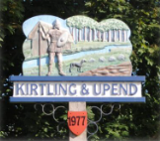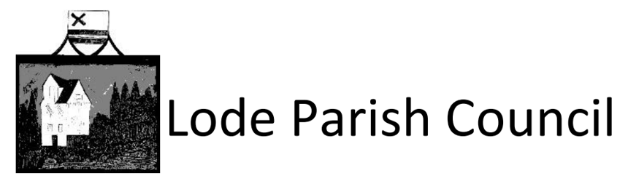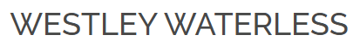

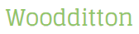
*non-quorate

ANNEX
Why is Cambridge important to us?
We are predominantly a rural area with limited local infrastructure, education and health services and retailing and leisure facilities. Our cultural connection to Cambridge is also very important to us.
Commuting
- Most of our residents who do not work in the local community work in Cambridge or South Cambridgeshire (see page 21 of the Business Case for Option 1).
- Public transport provision is limited and the vast majority of those commuting from our area to Cambridge have no choice but to drive. Rush hour congestion is a major and growing problem.
- We are already collaborating with the Greater Cambridge Partnership to start introducing active travel routes into the city from our villages north of the A14. We believe that this relationship would be greatly enhanced under Option 2.
- Improved collaboration under Option 2 arrangements would offer opportunities to strengthen bus and rail services. Some of our settlements have no viable bus links and our two train stations on the Ipswich to Cambridge line, Dullingham to the west of Newmarket and Kennett to the north-east, exist, but could be vastly improved. This rail line is being discussed as a further opportunity for EWR.
- All options other than Option 2 could result in long journeys for residents to access administrative centers, impacting vulnerable people the most, thus increasing inequality.
Education
- We have strong local primary schools but only one 11–16 secondary school. Bottisham Village College is an excellent, inclusive school, with a half of its students coming from our villages, and the remainder coming from Cambridge and South Cambridgeshire to the west or Newmarket (Suffolk) to the east.
- Our rural area relies heavily on Home to School Transport. With no special school provision in our area, those with EHCPs will likely face longer, more costly journeys to seek provision if we were part of a northern unitary.
- We have no post-16 provision in our area. Virtually all our young people aged over sixteen travel to Cambridge to progress their education. We value the quality of the education services provided there although accessing them can be challenging (see commuting above). This could be improved under Option 2.
- Only Option 2 protects our students’ continued access to post-16 education in Cambridge. Other options would create substantial financial pressures on authorities and families, requiring new facilities or costly new transport links.
- Adult learning opportunities are virtually non-existent without travelling to Cambridge
Healthcare
There is a strong relationship between Option 2 and alignment of local government services and the provision of healthcare. In support of what the health authorities have said in support of Option 2:
- We have two GP practices: one in Bottisham, the other in Burwell. Most of our residents rely on services in Newmarket (Suffolk).
- We have two small dental practices covering the whole of our area, meaning most residents need to find a service in Cambridge or Newmarket.
- All our Cambridgeshire-based hospital care is in Cambridge. Some using GPs in Newmarket currently have the option of West Suffolk Hospital to the east for some treatments.
- Social care in our area is extremely limited. We have pockets of rural deprivation and many isolated older residents whose support is declining. LGR offers opportunities to improve services, but only if geography and access are properly considered. With Ely further away than Cambridge or Newmarket, many residents struggle to reach help. Strengthening our links with Cambridge and South Cambridgeshire is the only realistic way to deliver the support our communities need.
Strengthening our connection to Cambridge is a win-win
- The proximity of our area to Cambridge allows opportunities for developments to the east of Cambridge, also being on the potential eastern leg of EWR, this offers further opportunities to the Oxford-Cambridge arc. A great number of our residents work in the targeted sectors of this initiative.
- A strong case for development near the railway line cutting through Six-Mile-Bottom in South Cambridgeshire has been put forward many times in the past. The land associated with this potential development covers very little land in the Six-Mile-Bottom parish itself but rather relies on bordering land across six of our parishes. Such a development would offer further scope for sustainable growth around Cambridge, it would also resolve capacity issues for Newmarket over the border in Suffolk and would strengthen our links to Cambridge, as well as opportunities to resolve the afore-mentioned infrastructure and service issues our communities face.
Alignment with Government Reorganisation Principles
The Government has been clear that new unitary authorities should reflect functional economic areas, travel-to-work patterns, service access and community identity, while enabling efficient and sustainable public service delivery.
Our communities already operate as part of the Greater Cambridge functional economy, with residents commuting to Cambridge for employment in sectors such as research, life sciences, education and technology. Healthcare, further education and transport networks are also primarily oriented towards Cambridge. Aligning our area within a Cambridge and South Cambridgeshire unitary would therefore support efficient service delivery, coherent strategic planning and governance that reflects the real geography of our communities, consistent with the principles outlined for Local Government Reorganisation.
Aligning our communities with a northern unitary centered many miles away would not reflect these functional relationships and risks creating a geographically peripheral area with weaker service integration.
Public Engagement
Many residents assumed we would naturally be connected to Cambridge, leading to some complacency during the LGR process. To address this, we used the final weeks of the consultation period to encourage participation and ensure people understood the potential outcomes.
We held three public engagement events across our two divisions and ran a short, accessible survey to gather wider views.
The feedback at the events was unanimous in supporting the position taken by the 16 parishes that had previously voted to support Option 2. Our events included a balanced panel, with a District Councillor presenting the case for Option 1. While some valued hearing another perspective, there was no support for it. Residents viewed alignment with a northern unitary as wasteful, unsettling and unnecessarily complex.
We had 261 responses to the local survey spread across the breadth of the area. Though this was a small sample size received in a short period, the outcomes are very decisive in confirming the approach we are making to you. Most notably 93% of respondents supported us being connected to Cambridge City and South Cambridgeshire in one way or other.
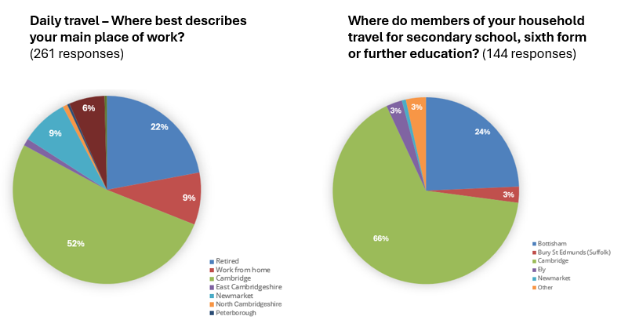
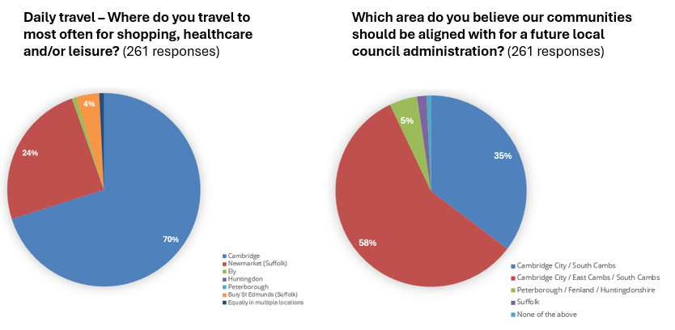
How important is it to you that local goverment boundaries reflect where you actually travel to work, healthcare and daily life? (261 responses)
Rating (1 to 5, 5 being highest) | Number of responses | Percentage
1 | 15 | 5.7%
2 | 15 | 5.7%
3 | 34 | 13%
4 | 196 | 75.1%
5 | 1 | 0.4%
Summary of our representation
- We are a combined voice from all levels of local government representing 16 of the 19 parishes in the Burwell and Woodditton County Divisions that had voted to support Option 2.
- In the final weeks of your public consultation, we engaged residents from all 19 parishes through three public engagement events and a survey. This demonstrated many were unfamiliar with LGR and what it might mean for our area, but that public opinion was unanimously in alignment with that of the 16 parishes.
- We judge that Option 2 is the only option being consulted on that is viable for our communities. It is also the best option for the rest of Cambridgeshire and the wider region, being best able to realise opportunities offered by the development of Greater Cambridge and the Oxford-Cambridge Arc.
- We are clear that if you are minded to favour other options, our connection to Cambridge and South Cambridgeshire must be retained (Appendix 2); without it, our communities would become geographically isolated and disadvantaged.

APPENDIX 1

FIRST DRAFT FOR PARISH FEEDBACK
Commuter map
All our main roads lead to Cambridge and South Cambridgeshire in one direction and Newmarket in the other. A14, A1303, A1304, B1061 and B1102.
All our buses, the few that exist, have final destinations in Cambridge or Newmarket.
Our only train line Ipswich to Cambridge has two stations in our divisions, Kennett and Dullingham. Between these two stations the line also passes through Newmarket.
There is a closed rail connection, called the Snailwell Loop, that could connect us to Soham and Ely, but it has been out of service since 4 January 1965. The potential to re-open this still exists, but has never been a priority of local or national government.

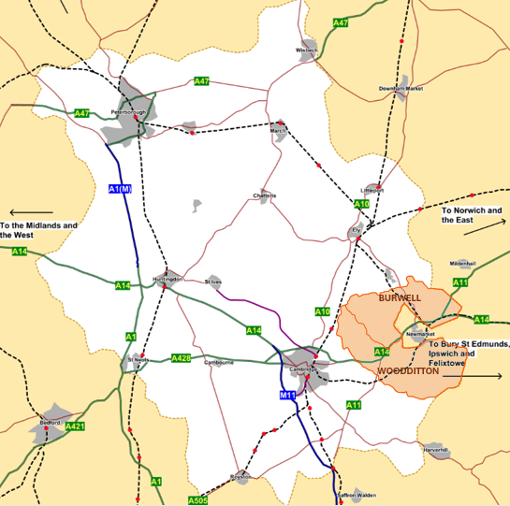

Railway lines Railway stations EWR proposals Guided busway
Major A roads Minor A roads Motorway

APPENDIX 2
Burwell and Woodditton Backstop
If Burwell and Woodditton divisions are decoupled from the remainder of East Cambridgeshire, and included with Cambridge City and South Cambridgeshire, a congruent area would be created.
North Cambridgeshire and Peterborough would serve approximately 593,000 people. Greater Cambridgeshire serving approximately 341,000 people.
We still believe Option 2 is the best solution, but we strongly feel this backstop is essential if you are considering alternatives.
